**The** **Empire** **State** **Building**

1. **Match the buildings to the countries:**

France Malaysia USA

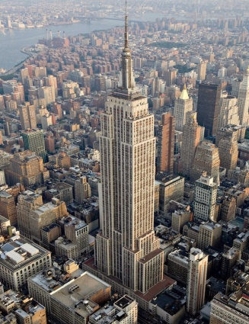 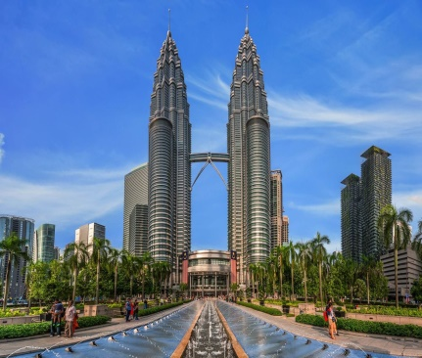 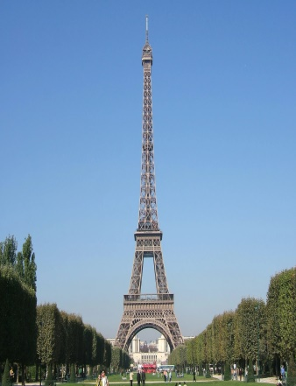

Petronas towers The Eiffel Tower The Empire State Building

**Complete the sentences:**

1. Petronas towers are in ________________.
2. The Eiffel Tower is in _________________.
3. The Empire State Building is in ______________.

1. **Read the text and tick True or False:**
2. The Empire State Building is the tallest building in the USA.
3. The ESB is one of the largest shopping center in the world, but it also has many shops and restaurants inside.
4. The Empire State Building has 73 super-fast lifts.
5. Lots of people work inside The Empire State Building.
6. You can get to the top of The Empire State Building in 45 seconds.
7. The most amazing view of the city is from the 60th floor.
8. The lights on the top floors of the Empire State Building change colours many times a day.
9. **Read the text and find as many adjectives as you can:**

|  |  |  |
| --- | --- | --- |
| **Positive degree**  **(small)** | **Сomparative degree (smaller)** | **Superlative degree**  **(The smallest)** |
|  |  |  |
|  |  |  |
|  |  |  |
|  |  |  |
|  |  |  |

1. **Find in the text and write in English:**
2. офисные здания - _______________________________
3. супер скоростные лифты - ________________________________
4. подняться на самый верх -_________________________________
5. большинство посетителей - ________________________________
6. ясный день - ____________________________________________
7. верхние этажи - __________________________________________
8. красивыми огнями - ______________________________________
9. меняют цвет - _________________________________
10. в зависимости от ситуации - ___________________________
11. самое историческое здание - ____________________________
12. **Answer the question:**

What is the Empire State Building?

______________________________________________________________________________________________________________________________________________________________________________________________________________________________________________________________________________________________________________________________________________________________________________________________________________________________