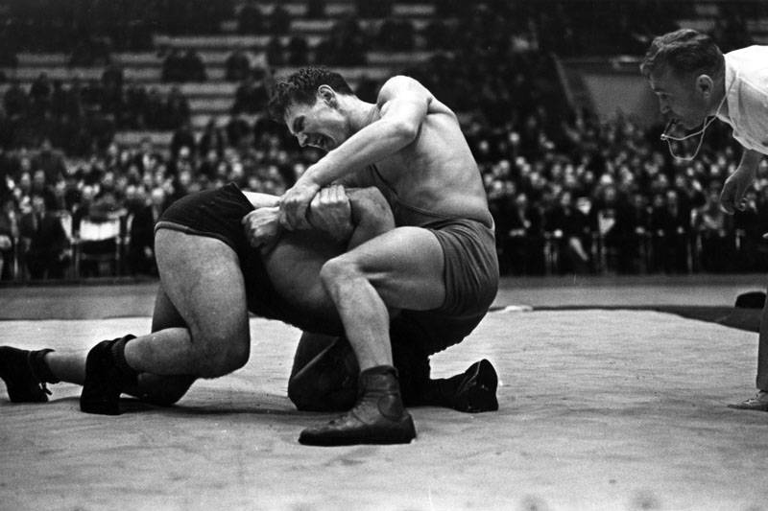

**The Olympic Champion Alexandr Medved Gives Advice**

A wrestler must have many qualities to beat his rivals. He must be strong and very quick. Then he needs enough strength to tear the rival from the mat and throw him on the floor.

I will tell you about myself. I grew up tall and thin with no great strength in my arms. Wrestling came into my life when I was 18. I was 188 cm tall and weighed 85 kg and could not compete with my rivals in strength.

Then I decided to build up my muscles. I developed a system of exercises, which helped me to become stronger. I spent much time weight lifting. I lifted a bar equal to my own weight, which is up to 100 kg. However, that happened after two years of regular exercising. At first, the weight was only 30-40 kg. In general, I advise to choose the weight, which is twice as small as your own.

Push-ups were also of great help to me. At first, I could push up only 3 or 4 times, so weak were my arms! Then 30 times. Interesting enough, if you strengthen your legs, you feel as if your body has become much lighter. It is a very useful exercise. I also worked with dumb-bells and weights and threw heavy stones into air. You must combine muscle-building exercises with long distance running. It is a good relaxation for the arms and back muscles.

I was considered the strongest heavyweight wrestler in the world. However, I have never been the biggest among my rivals. I weighed a little over 100 kg but defeated even those who weighed 120, 150 and 180 kg like the American Chris Taylor whom I threw on the floor at the 1972 Olympics. If you are strong, you do not fear any rivals! My advice to you is if you want to be strong, take up physical exercises at once.

**Exercise 1.**Choose the right answer.

1. The sportsman is
2. boxer b) a wrestler,   c) a runner
3. He began to do sports when he was
4. 15. b) 17.    c)  18.
5. If you strengthen your legs, you feel as if your body has become
6. much lighter b) heavier c) smaller

4. Long distance running is a good relaxation for

1. Your mind b) the arms and back muscles c) the leg muscles

**Exercise 2.** Say if the statements are true or false.

1. Alexandr Medved grew up tall and thin with no great strength in his arms.
2. When he was 18, he could easily compete with his rivals in strength.
3. At first, he lifted a bar equal to only 30-40 kg.
4. After a year of regular exercising, he lifted a bar equal to 100 kg.
5. Push-ups were not of great help to him.

**Exercise 3.**Insert the words, according to the text.

1. A wrestler must have many qualities to __________ his rivals.
2. ____________came into my life when I was 18.
3. Then I decided to build up my ___________.
4. At first, I could push up only 3 or 4 times, so weak were my ___________
5. I weighed a little over 100 kg but ______________ even those who weighed 120, 150 and 180 kg

**Exercise 4.**Answer the questions.

1. What qualities must a wrestler have to beat his rivals?
2. What advice does A. Medved give about choosing the weight for the weight lifting exercises?
3. How can a person become strong?

